**Home Equity Reverse Mortgage Information Technology**

**(HERMIT)**

**HERMIT System Changes – Release 5.7**

**Release Date: 12/15/18**

**Document Date: 12/14/18**

December 2018

Version 1.0

**INTRODUCTION**

The Home Equity Reverse Mortgage Information Technology (HERMIT) software release version 5.7 consists of the following system changes:

Table of Contents

Servicer related changes 1

1 Claims – Modified Expired Appraisal Validation (563989) 1

2 Supplemental Over Claims Transactions (563909) 5

3 Updated Termination Pop-up Message (539380) 5

4 Allow Servicer to Initiate a Claim if there was a Claim Type 22 and a Repurchase (560669) 6

5 Remove Default Reason “Unpaid Taxes & Unpaid Insurance” for Endorsed and Assigned loans 6

NSC related changes 6

1 NSC – Allow HUD NSC Contractor to terminate a loan when there is a HUD Advance and Claim Type 22 - Assignment Claims Paid step is completed. 6

2 NSC – Update Default Reason Codes on Assigned Loans (562735) 6

3 NSC – Updated HUD Security Permissions (544387) 9

4 NSC – Updated Security Permission for HUD NSC Contractor - First Mortgage: cannot initiate disbursements. (539355) 10

5 NSC – Updated Security Permission for HUD NSC Staff: alerts (565470) 10

If you have any questions regarding the functionality of the software release, please contact the HERMIT Help Desk at 561-899-2610 or at [servicingsupport@hermitsp.com](mailto:support@hecmsp.com). If you have any policy related questions, please send an email to HUD at [answers@hud.gov](mailto:answers@hud.gov).

# Servicer related changes

## Claims – Modified Expired Appraisal Validation (563989)

Previously during the claim validation process, 3 different validations were utilized to verify whether the appraisal was valid. The 3 separate validations have been consolidated and modified to act as one validation with multiple conditions listed below.

HERMIT still prevents the filing of the claim with a hard stop if the appraisal date from the claim disposition screen is not valid. The validation still does not apply to CT21 3rd Party Sale. If the validation passes after checking all conditions, the servicer may proceed in submitting the claim. If the validation fails, the claim may not be filed unless the failed conditions are resolved by entering a valid Appraisal Date in the claims disposition screen. The following changes have been made to the validation rules for Expired Appraisal:

1. **Appraisal Expired** will be performed first. For this condition to pass, the Sale Closing date (for CT23) or Block 10 date (for CT21) must occur between the Appraisal Date and the Appraisal Date plus 120 days. **If this condition PASSES, the 2 subsequent expired appraisal validations shall not be performed and the claim may be filed.**
   1. Claim Type 23: Condition **fails** if
      1. Either the “Sale Closing Date” is BEFORE “Appraisal Date”
      2. OR the “Sale Closing Date” is AFTER “Appraisal Date +120 days”
   2. Claim Type 21 – Sale Based Claim: Condition **fails** if
2. Either the “Block 10” is BEFORE “Appraisal Date”
3. OR “Block 10” is AFTER “Appraisal Date +120 days”
   1. Claim Type 21 – Appraisal Based Claim: Condition **fails** if
4. Either the “Block 10” is BEFORE “2nd Appraisal Date”
5. OR the “Block 10” is AFTER “2nd Appraisal Date +120 days”.

*IMPORTANT: 2nd Appraisal Date is on the Claims Disposition Screen underneath the Appraisal Based Claim radio button.*

* 1. Examples
     + Example 1: Sale Closing Date 08/01/18 is BEFORE Appraisal Date 10/15/18, therefore this condition fails.
     + Example 2: Appraisal Date is 08/01/18. Block 10 date 12/10/18 is AFTER Appraisal Date +120: 11/29/18, therefore this condition fails.
     + Example 3: Block 10 date 08/01/18 is BEFORE 2nd Appraisal Date 10/15/18, therefore this condition fails.

1. **Extension Expiration Date of Expired Appraisal** will be performed after condition “Appraisal Expired” if it has failed. For this condition to pass, the “Extension Expiration Date” from the Extension – Appraisal timeline must be populated and must be after the Sale Closing date (CT23) or Block 10 date (CT21). **If this condition PASSES, the remaining expired appraisal validations shall not be performed and the claim may be filed.**
   1. Claim Type 23: Condition **fails** if “Sale Closing Date” is AFTER “Extension Expiration Date” from the Extension – Appraisal timeline
   2. Claim Type 21 (Sale Based Claim AND Appraisal Based Claim): Condition **fails** if “Block 10” is AFTER “Extension Expiration Date” from the Extension – Appraisal timeline
   3. Examples
      1. Example 1: Sale Closing Date 08/01/18 is AFTER Extension Expiration Date 07/15/18, therefore this condition fails.
      2. Example 2: Block 10 Date 10/01/18 is AFTER Extension Expiration Date 09/20/18, therefore this condition fails.
2. **Appraisal Late** will be performed after condition “Extension Expiration Date of Expired Appraisal” if it has failed. If there was not an “Extension Expiration Date” from an approved “Extension – Appraisal” timeline, this condition will be checked if 1st condition “Appraisal Expired” has failed. For this condition to pass, the Appraisal Date must occur between the Sale Closing date plus 1 day and the Sale Closing date plus 120 days (CT23) or the Block 10 date plus 1 day and the Block 10 date plus 120 days (CT21). **If this condition PASSES, the claim may be filed and no expired appraisal validation message is displayed.**

*Important****:*** *other claim validations are still applicable and the claim can fail another validation regardless of whether the Expired Appraisal passes or fails.*

* 1. Claim Type 23: Condition **fails** if
     1. Either the “Appraisal Date” is BEFORE “Sale Closing date”
     2. OR the “Appraisal Date” is AFTER “Sale Closing date +120 days”
  2. Claim Type 21 – Sale Based Claim: Condition **fails** if
     1. Either the “Appraisal Date” is BEFORE “Block 10 date”
     2. OR “Appraisal Date” is AFTER “Block 10 date +120 days”
  3. Claim Type 21 – Appraisal Based Claim: Condition **fails** if
     1. Either the “2nd Appraisal Date” is BEFORE “Block 10 date”
     2. OR “2nd Appraisal Date” is AFTER “Block 10 date +120 days”

*IMPORTANT: 2nd Appraisal Date is on the Claims Disposition Screen underneath the Appraisal Based Claim radio button.*

* 1. Examples:
     1. Example 1: Appraisal Date 07/01/18 is BEFORE Sale Closing date 11/15/18, therefore this condition fails.
     2. Example 2: Block 10 date is 04/30/18. Appraisal Date 10/01/18 is AFTER Block 10 date + 120 days: 08/28/18, therefore this condition fails.
     3. Example 3: 2nd Appraisal Date 07/15/18 is BEFORE Sale Closing date 12/13/18, therefore this condition fails.

1. **Validation Message**: If the hard stop applies for a failed Expired Appraisal, the validation message will read:
   1. For Claim Type 23: “The Appraisal is considered invalid. Please review the Appraisal Date entered on the Claims Disposition screen. For Appraisal to be compliant: Sale Closing Date must occur within either 120 days of the Appraisal Date, OR before the Extension Expiration Date of Approved Extension – Appraisal (If applicable). For Late Appraisals, the Appraisal Date must be no later than 120 days after Sale Closing Date.”
   2. For Claim Type 21: “The Appraisal is considered invalid. Please review the Appraisal Date entered on the Claims Disposition screen. For Appraisal to be compliant: Block 10 must occur within either 120 days of the Appraisal Date, OR before the Extension Expiration Date of Approved Extension – Appraisal (If applicable). For Late Appraisals, the Appraisal Date must be no later than 120 days after Block 10.”

## Supplemental Over Claims Transactions (563909)

**Two new Over Claims Transactions are added under Transactions/Claims:**

* Claim Type 21 – Supplemental Over Claim
* Claim Type 23 – Supplemental Over Claim

The Supplemental Over Claim transactions will only be available for selection when the applicable supplemental transaction was paid by HUD.

* Example 1: If a Claim Type 21 and CT21 Supplemental were filed and Paid in HERMIT then a CT 21 Over Claim and 21 Supplemental Over Claim transaction will appear
* Example 2: If a Claim Type 23 and CT23 Supplemental were filed and Paid in HERMIT then a CT 23 Over Claim and 23 Supplemental Over Claim transaction will appear

The Supplemental Over Claim transactions will be subject to all other rules previously applied to the “Claim Type 24 Over Claim” transaction.

**Inactivate Existing “Claim Type 24 – Over Claim” transaction**

From the release date going forward, the “Claim Type 24 - Over Claim” transaction cannot be created by the user.

An update will be made to existing transaction types “Claim Type 24 - Over Claim” to the corresponding new transaction:

* If the parent claim was CT21, the Claim Type 24 - Over Claim transaction shall be updated to “Claim Type 21 – Supplemental Over Claim”
* If the parent claim was CT23, the Claim Type 24 - Over Claim - transaction shall be updated to “Claim Type 23 – Supplemental Over Claim”

Over Claim Report will have these new transactions added and can be selected to run report.

## Updated Termination Pop-up Message (539380)

**Updated pop-up warning message**

When loan is terminated in HERMIT, a pop-up warning message is displayed. The warning message has been updated:

* Previous message: Processing this Loan Transaction will change the Case Status to Terminated
* New message: Processing this Loan Transaction will change the Case Status to Terminated. You should re-verify that you are using the correct termination transaction type for this action prior to submitting.



**Figure 1: New Termination Message**

## Allow Servicer to Initiate a Claim if there was a Claim Type 22 and a Repurchase (560669)

**Claim Type 22 with Confirmed Repurchase**

Authorized users shall be permitted to initiate a new claims timeline if all the following conditions apply:

* There is a Claim transaction in the Transactions --> Claim page where the transaction code is = 3422 “Claim Type 22 – Optional Assignment”
* There is a Request for HUD Advance (Assignment) Timeline with step completed date “Assignment to Servicer sent for Recording” populated

The logic applies to both ACTIVE and INACTIVE Request for HUD Advance (Assignment) Timelines

If the claim type 22 was a paper claim, the 2nd assignment timeline after repurchase is allowed.

## Remove Default Reason “Unpaid Taxes & Unpaid Insurance” for Endorsed and Assigned loans

The default reason “Unpaid Taxes & Unpaid Insurance” has been removed from the available dropdown list for Endorsed and Assigned when creating new timelines or editing existing timelines.

The user will have to either choose “Unpaid Taxes” or “Unpaid Insurance” but it can no longer be both.

# NSC related changes

## NSC – Allow HUD NSC Contractor to terminate a loan when there is a HUD Advance and Claim Type 22 - Assignment Claims Paid step is completed.

If the "Claims Paid" step from the active Claim Type 22 - Assignment timeline is completed and the servicer on the loan is the HUD NSC Contractor then allow the user to terminate the loan regardless of whether there is an active or inactive Request for HUD Advance (Assignment) timeline.

## NSC – Update Default Reason Codes on Assigned Loans (562735)

1. The Default Reason codes in the dropdown for Assigned 🡪 Due & Payable timeline have been updated to **match** the Endorsed Default Reason Codes. Previously the Assigned default reason options were displayed as paragraphs.

1. The new default reasons will be displayed for the user to select from when either the Assigned 🡪 Due & Payable timeline OR Assigned 🡪 Loss Mitigation – Pre Foreclosure timelines are created.

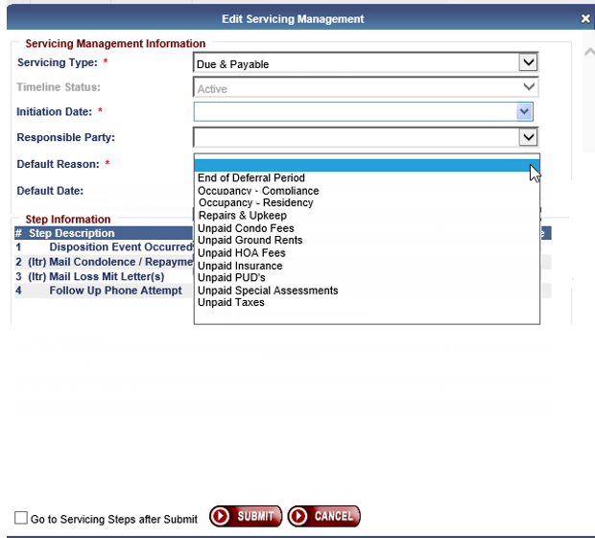

**Figure 2: Updated Default Reason Codes**

1. The new default reasons will be displayed for the user to select from when the user edits the default reason from the Servicing Management screen for the Assigned 🡪 Due & Payable timeline OR Assigned 🡪 Loss Mitigation – Pre Foreclosure timelines. The paragraph is mapped to the default reason on the Servicing Management screen as defined in table 2.1.3 below.

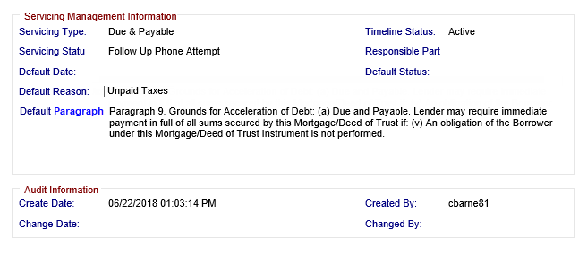

**Figure 4: Updated Unpaid Taxes**

1. Default Reason “Death”
   1. For the Assigned 🡪 Due & Payable timeline - Death (death date added to all borrowers, the appropriate death paragraph is automatically populated by the system. When the user attempts to create or edit an Assigned 🡪 Due & Payable timeline "Death" will not appear in the Default Reason dropdown. The Assigned Due & Payable timelines will only set “Death” when the all borrower(s) deceased. Once this default reason is set it cannot be changed or edited.
   2. For the Assigned 🡪 Loss Mitigation - Pre-Foreclosure timeline the default reason "Death" will be available under the dropdown to add or edit for this timeline. This only applies to the Assigned Loss Mitigation - Pre-Foreclosure.
2. Mapping of Endorsed Default Reason codes to Assigned Default Reason paragraphs are displayed in Table 2.1.3:

| **Endorsed Default Reason** | **Assigned Default Reason Desc** | **Assigned Default Reason Desc** |
| --- | --- | --- |
| Death (20) **NOTE:** This reason is auto selected when loan is Due & Payable - Death. Existing functionality (Due & Payable timeline)  Loss Mitigation – Pre-Foreclosure timeline – This is not automatically selected. | Reason 1 | Paragraph 9. Grounds for Acceleration of Debt: (a) Due and Payable.  Lender may require immediate payment in full of all sums secured by this Mortgage/Deed of Trust if: (i) A Borrower dies and the Property is not the principal residence of at least one surviving Borrower. |
| Conveyed Title (10) | Reason 2 | Paragraph 9. Grounds for Acceleration of Debt: (a) Due and Payable.  Lender may require immediate payment in full of all sums secured by this Mortgage/Deed of Trust if: (ii) All of a Borrower's title in the Property (or his or her beneficial interest in a trust owning all or part of the Property) is sold or otherwise transferred and no other Borrower retains title to the Property in fee simple or retains a leasehold under a lease for not less than 99 years which is renewable or a lease having a remaining period of not less than 50 years beyond the date of the 100th birthday of the youngest Borrower or retains a life estate (or retaining a beneficial interest in a trust with such an interest in the Property). |
| Occupancy - Residency (12) | Reason 3 | Paragraph 9. Grounds for Acceleration of Debt: (a) Due and Payable.  Lender may require immediate payment in full of all sums secured by this Mortgage/Deed of Trust if: (iii) The property ceases to be the principal residence of a Borrower for reasons other than death and the Property is not the principal residence of at least one other Borrower. |
| Occupancy - Compliance (140) | Reason 4 | Paragraph 9. Grounds for Acceleration of Debt: (a) Due and Payable.  Lender may require immediate payment in full of all sums secured by this Mortgage/Deed of Trust if: (iv) For a period of longer than twelve (12) consecutive months, a Borrower fails to occupy the Property because of a physical or mental illness and the Property is not the principal residence of at least one other Borrower. |
| Repairs & Upkeep (130)  Unpaid Insurance (150)  Unpaid Taxes (160)  Unpaid Ground Rents (1270)  Unpaid Condo Fees (1280)  Unpaid PUD's (1300)  Unpaid HOA Fees (1310)  Unpaid Special Assessments (1320)  End of Deferral Period (1330) | Reason 5 | Paragraph 9. Grounds for Acceleration of Debt: (a) Due and Payable.  Lender may require immediate payment in full of all sums secured by this Mortgage/Deed of Trust if: (v) An obligation of the Borrower under this Mortgage/Deed of Trust Instrument is not performed. |

1. Existing Data update

During the 5.7 Release, default reasons that were displayed as paragraphs will be updated to the new mapping for existing Assigned timelines.

## NSC – Updated HUD Security Permissions (544387)

* Allow HUD NSC Staff to create and update editable Disposition steps for Endorsed and Assigned loans
* Allow HUD NSC Staff to view and update editable Endorsed Requests Steps
* Remove the create permission for Endorsed Request timelines for the following user roles:
  + HUD NSC Staff
  + HUD SF Premium Mgr.
  + HUD SF Staff
* NOTE: no changes were made to individual timeline steps that are locked down and do not allow editing of completion dates. These dates still cannot be edited by users.

## NSC – Updated Security Permission for HUD NSC Contractor - First Mortgage: cannot initiate disbursements. (539355)

* Remove the permission so HUD NSC Contractor - First Mortgage cannot initiate disbursements.

## NSC – Updated Security Permission for HUD NSC Staff: alerts (565470)

* Allow HUD NSC Staff to create and edit Alerts